Lab Modul 8

1. Create a view named ‘ViewBonus’ to display BinusId (obtained from CustomerID by replacing the first 2 characters with ‘BN ’), and CustomerName for every customer whose name is more than 10 characters. (create view, stuff, len)

CREATE VIEW ViewBonus AS

SELECT STUFF(CustomerId,1,2,'BN') AS BinusId,

CustomerName

FROM MsCustomer

WHERE LEN(CustomerName) >10;

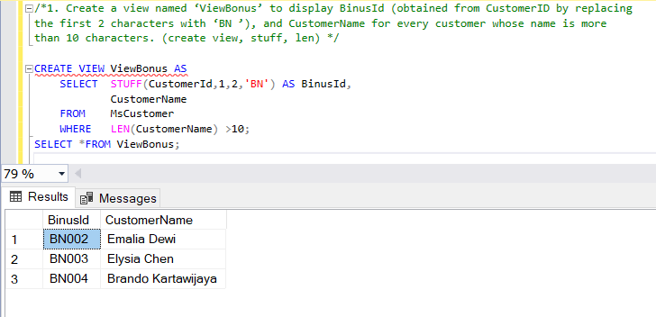SELECT \*FROM ViewBonus;

2. Create a view named ‘ViewCustomerData’ to display Name (obtained from customer’s name from the first character until a character before space), Address (obtained from CustomerAddress), and Phone (obtained from CustomerPhone) for every customer whose name contains space. (create view, substring, charindex)

CREATE VIEW ViewCustomerData AS

SELECT SUBSTRING(MsCustomer.CustomerName,1,CHARINDEX(' ', MsCustomer.CustomerName)) AS [Name],

CustomerAddress AS [Address],

CustomerPhone AS Phone

FROM MsCustomer

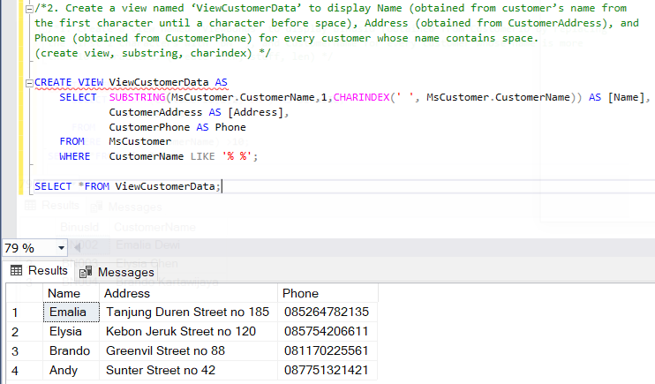 WHERE CustomerName LIKE '% %';

SELECT \*FROM ViewCustomerData;

3. Create a view named ‘ViewTreatment’ to display TreatmentName, TreatmentTypeName, Price (obtained from Price by adding ‘Rp. ’ in front of Price) for every treatment which type is ‘Hair Treatment’ and price is between 450000 and 800000. (create view, between)

CREATE VIEW ViewTreatment AS

SELECT TreatmentName,

TreatmentTypeName,

CONCAT('Rp. ',Price) AS Price

FROM MsTreatment, MsTreatmentType

WHERE MsTreatmentType.TreatmentTypeId = MsTreatment.TreatmentTypeId AND

Price BETWEEN 450000 AND 800000;

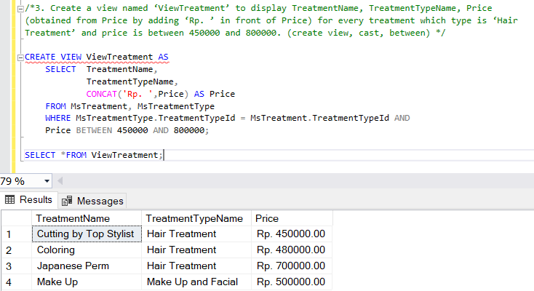SELECT \*FROM ViewTreatment;

4. Create a view named ‘ViewTransaction’ to display StaffName, CustomerName, TransactionDate (obtained from TransactionDate in ‘dd mon yyyy’ format), and PaymentType for every transaction which the transaction is between 21st and 25th day and was paid by ‘Credit’. (create view, convert, day, between)

CREATE VIEW ViewTransaction AS

SELECT StaffName,

CustomerName,

CONVERT(VARCHAR,TransactionDate,106) AS TransactionDate,

PaymentType

FROM MsStaff,MsCustomer,HeaderSalonServices

WHERE MsStaff.StaffId = HeaderSalonServices.StaffId AND

MsCustomer.CustomerId = HeaderSalonServices.CustomerId AND

DAY(TransactionDate) BETWEEN '21' AND '25' AND

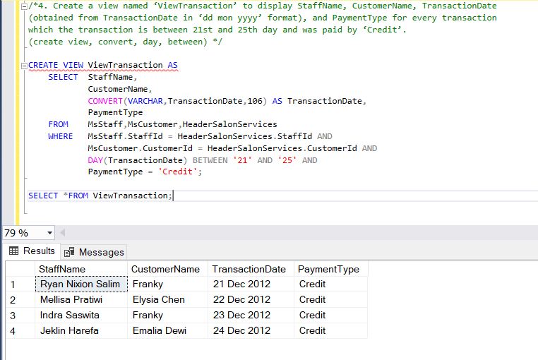 PaymentType = 'Credit';

5. Create a view named ‘ViewBonusCustomer’ to display BonusId (obtained from CustomerId by replacing ‘CU’ with ‘BN’), Name (Obtained from CustomerName by taking the next character after space until the last character in lower case format), Day (obtained from the day when the transaction happened), and TransactionDate (obtained from TransactionDate in ‘mm/dd/yy’ format) for every transaction which customer’s name contains space and staff’s last name contains ‘a’ character. (create view, replace, lower, substring, charindex, len, datename, weekday, convert, like)

CREATE VIEW ViewBonusCustomer AS

SELECT REPLACE(MsCustomer.CustomerId,'CU','BN') AS BonusId,

LOWER(SUBSTRING(CustomerName,CHARINDEX(' ',CustomerName) +1,LEN(CustomerName))) AS [Name],

DATENAME(WEEKDAY,TransactionDate) AS [Day],

CONVERT(VARCHAR,TransactionDate,101) AS TransactionDate

FROM MsCustomer,MsStaff,HeaderSalonServices

WHERE MsCustomer.CustomerId = HeaderSalonServices.CustomerId AND

MsStaff.StaffId = HeaderSalonServices.StaffId AND

CustomerName LIKE '% %' AND

RIGHT(StaffName,1) = 'a';

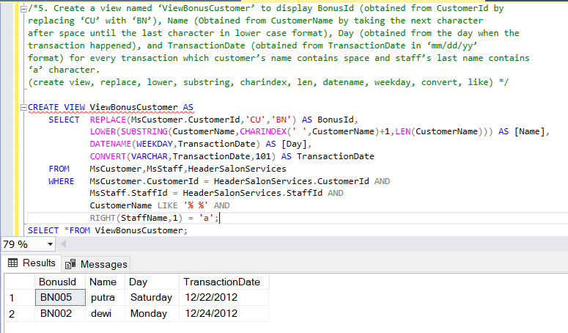SELECT \*FROM ViewBonusCustomer;

6. Create a view named ‘ViewTransactionByLivia’ to display TransactionId, Date (obtained from TransactionDate in ‘Mon dd, yyyy’ format), and TreatmentName for every transaction which occurred on the 21st day and handled by staff whose name is ‘Livia Ashianti’. (create view, convert, day, like)

CREATE VIEW ViewTransactionByLivia AS

SELECT HeaderSalonServices.TransactionId,

CONVERT(VARCHAR,TransactionDate,107) AS TransactionDate,

TreatmentName

FROM HeaderSalonServices, MsTreatment, DetailSalonServices, MsStaff

WHERE HeaderSalonServices.TransactionId = DetailSalonServices.TransactionId AND

DetailSalonServices.TreatmentId = MsTreatment.TreatmentId AND

HeaderSalonServices.StaffId = MsStaff.StaffId AND

DAY(TransactionDate) = '21' AND

StaffName LIKE 'Livia Ashianti';

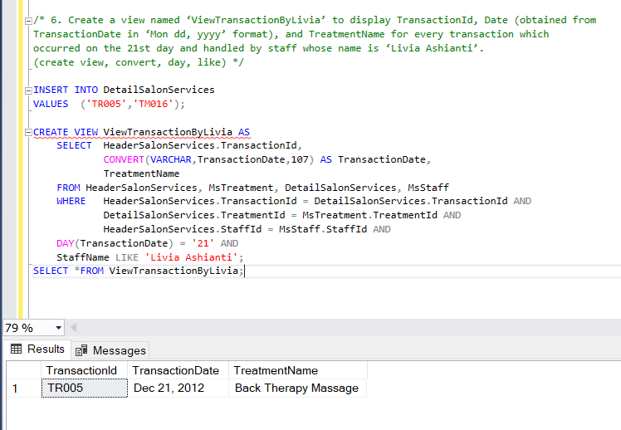SELECT \*FROM ViewTransactionByLivia;

7. Change the view named ‘ViewCustomerData’ to ID (obtained from the last 3 digit characters of CustomerID), Name (obtained from CustomerName), Address (obtained from CustomerAddress), and Phone (obtained from CustomerPhone) for every customer whose name contains space. (alter view, right, charindex)

ALTER VIEW ViewCustomerData AS

SELECT RIGHT(CustomerId,3) AS ID,

CustomerName AS [Name],

CustomerAddress AS [Address],

CustomerPhone AS 'Phone' FROM MsCustomer

WHERE CustomerName LIKE '% %';

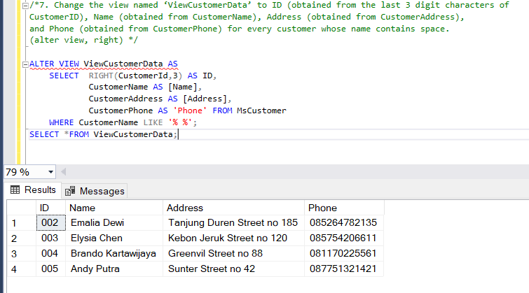SELECT \*FROM ViewCustomerData;

8. Create a view named ‘ViewCustomer’ to display CustomerId, CustomerName, CustomerGender from MsCustomer, then add the data to ViewCustomer with the following specifications:

CREATE VIEW ViewCustomer AS

SELECT CustomerId,

CustomerName,

CustomerGender

FROM MsCustomer;

INSERT INTO ViewCustomer (CustomerId, CustomerName, CustomerGender)

VALUES ('CU006','Cristian','Male');

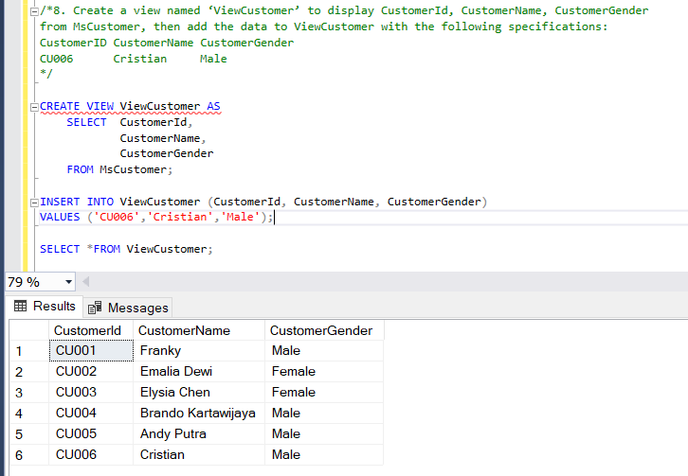SELECT \*FROM ViewCustomer;

9. Delete data in view ‘ViewCustomerData’ that has ID ‘005’. Then display all data from ViewCustomerData. (delete)

DELETE FROM ViewCustomerData

WHERE ID = '005';

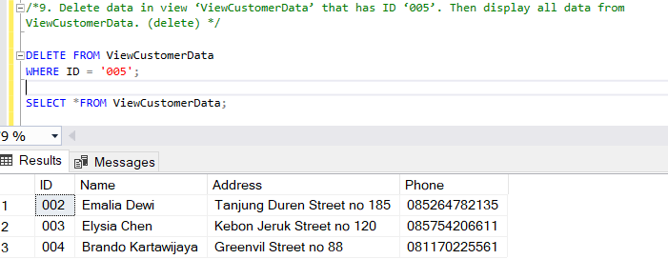SELECT \*FROM ViewCustomerData;

10. Delete the view named ‘ViewCustomerData’. (drop view)

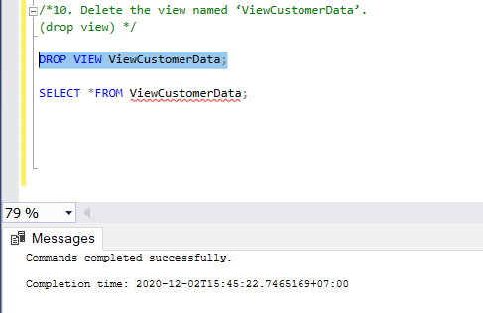DROP VIEW ViewCustomerData;

SELECT \*FROM ViewCustomerData;